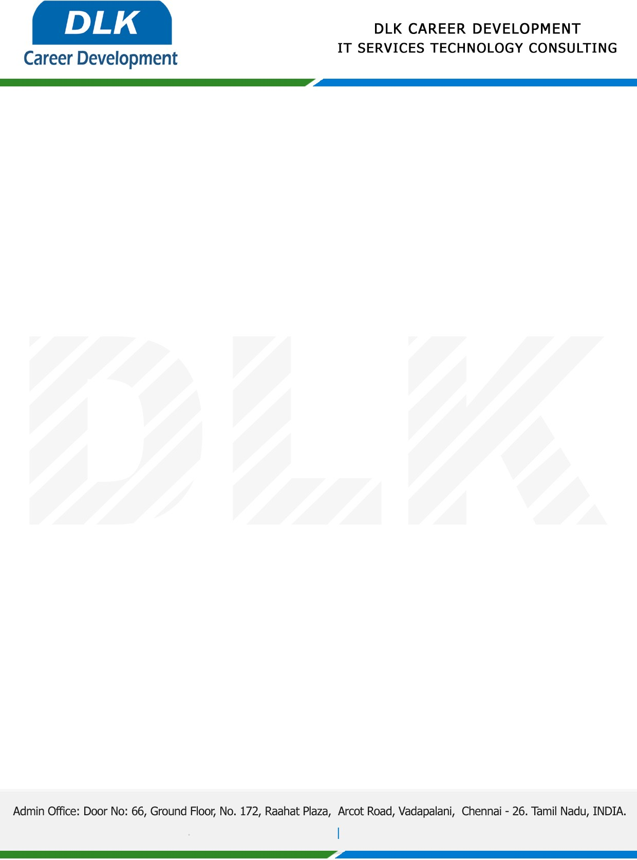

**Date: 01/ April /2023**

**SUB: PROJECT COMPLETION CERTIFICATE**

This is to certify that **MR SUSIL KUMAR C K (REG NO:** **41410323) MBA- Finance,** final year student **Sathyabama Institute of Science and Technology, Chennai** has Successfully Completed the Project Work under the domain of “**Finance”** in our organization during the Period **(02nd February 2023** to **31st March 2023).**

**Topic:** A Study of Impact on Profitability Due to Investment on Inventory Management

**“Best Wishes for Your Future Endeavors “**